Identity DAO Spec v0.3



dOrg – GoodDollar Project

06.18.19

II. Architecture

The smart contract architecture for the Identity DAO project is fairly simple; the DAO Avatar keeps control over the IdentityRegistryScheme contract, which acts as an interface for any validated user to propose adding, removing, or updating, a registered Identity. All proposals are stored within a mapping in the contract, as proposalIDs => IdentityProposal structs. Because the add, remove, and update functions all have different values of parameters, the struct simply holds these parameters as a single ABI-encoded value – bytes32.

On execution through the executeProposal() function, the contract will look up the proposal within the mapping, delete it (to prevent re-entrancy), and, based on the ProposalType enum value, destruct the values variable as expected.

The IdentityRegistryScheme contract, in turn, controls the IdentityRegistry itself. The IdentityRegistry contract can be seen as an isolated contract concerned only with the manipulation of the registry itself. In executing particular proposals, the Scheme contract will call the appropriate function on IdentityRegistry. These functions are restricted to the scheme contract, ensuring that DAO voting is required for using them.

The next few pages will provide an overview of this architecture, alongside sample psuedo-code in Solidity.

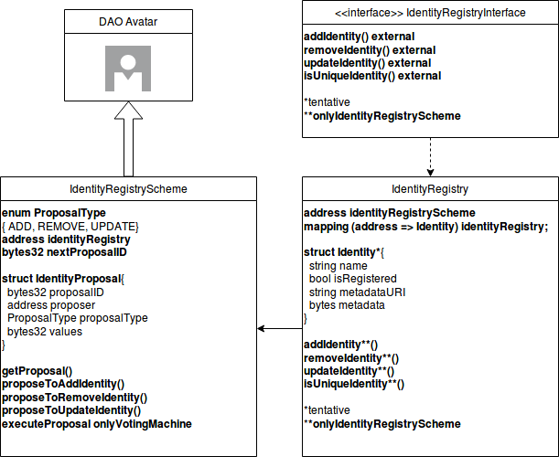

Sample Code:

IdentityRegistryInterface.sol

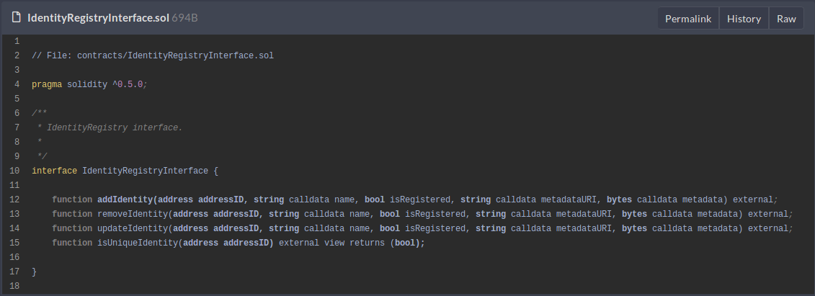
IdentityRegistry.sol

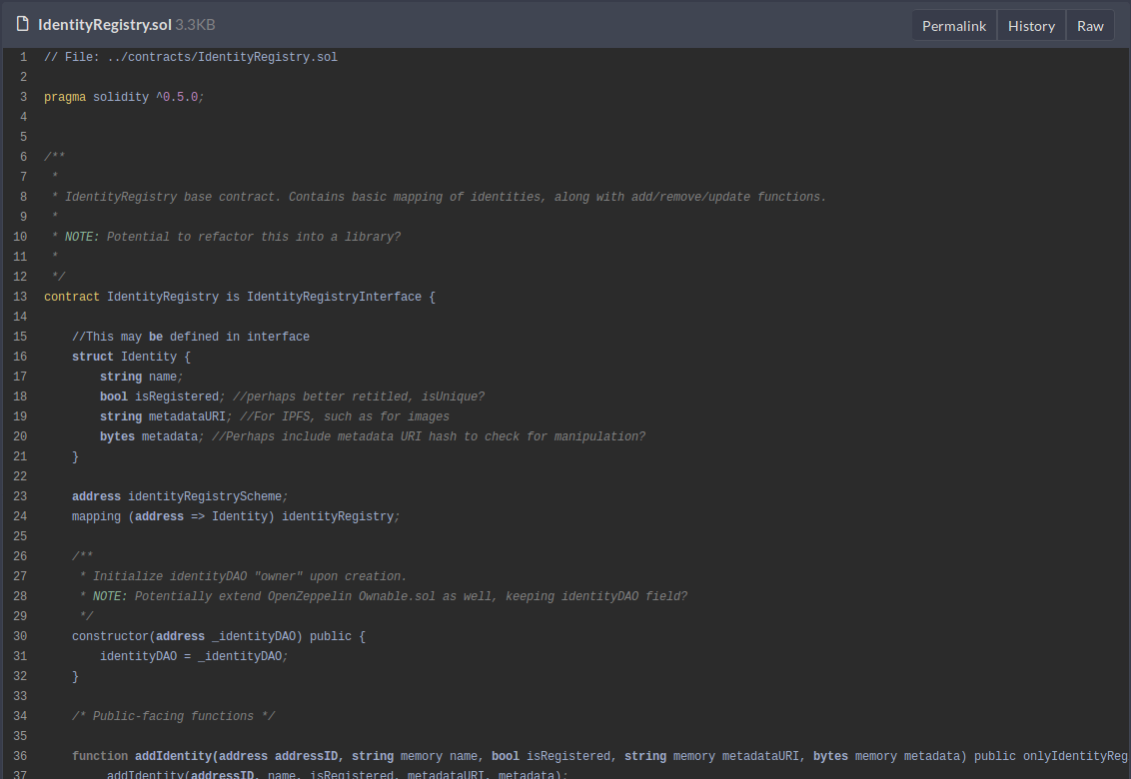
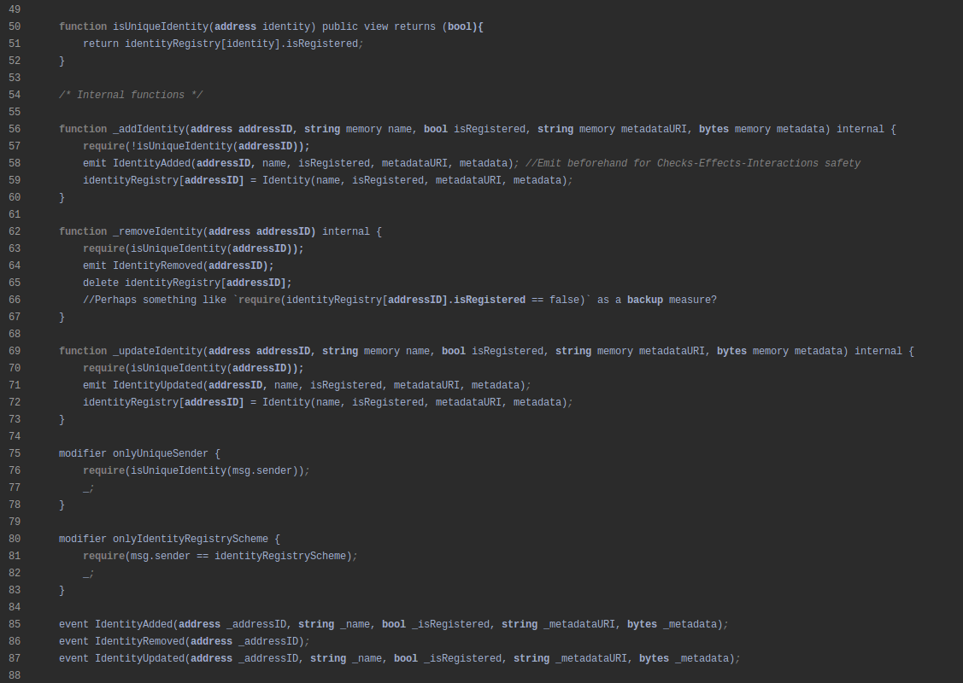

IdentityRegistryScheme.sol

